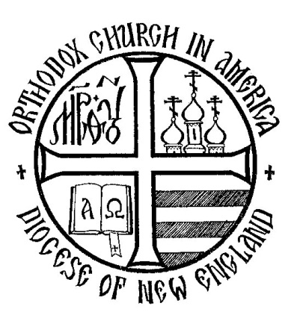

DIOCESE OF NEW ENGLAND

*53rd DIOCESAN ASSEMBLY*

Springfield, MA

**OCTOBER 28-29, 20156**

To the Reverend Clergy, Parish Councils and Faithful of the Diocese of New England,

The 53rd New England Diocesan Assembly will convene on October 28-29, 2016, hosted by Sts. Peter & Paul Church, Springfield, MA. Registration begins on Friday morning at 8:30 A.M. Clergy and Lay delegates are reminded that this is a two-day assembly, and all are expected to be present for the entire assembly.

Details regarding overnight accommodations, registration for the assembly - including delegate accreditation forms and travel details are included in this attachment. In the second attachment please find the draft minutes from the 52nd Diocesan Assembly. Another email, early in September, will contain the proposed budget for 2016. All parishes are receiving this packet in electronic form only.

Please note that the deadline for the rooms is September 27th, the forms and banquet registration are **October 8th**. Please make every attempt to attend the banquet.

As indicated in the Statute of the Orthodox Church in America, the parish lay representative(s) are to be chosen by election — either at a general parish meeting or a parish council meeting, according to local practice. The number of lay representatives corresponds to the number of assigned (not attached) clergy — priests and deacons — in the parish. Vacant parishes may elect and send one (1) lay representative. Accordingly, lay representation to the 53rd Assembly is on the enclosed sheet.

In order to send voting delegates to the Diocesan Assembly, parishes must be current with their Diocesan and OCA Fair Share that is at least through the fiscal year just ended on August 31, 2016. Please note that lay delegates whose parish fair share is not current will be seated as observers.

Sincerely yours in Christ,

**Alexia Tassmer**

|  |
| --- |
| **+ Nikon**  **Archbishop of Boston, New England and the Albanian Archdiocese**  **Orthodox Church in America** |
| **Most Rev. Nikon (Liolin) P.O. Box 149 Southbridge, MA 01550 508 -764 - 3222**  **Email: bpnikon@aol.com** |

August 2016

My Dear Brothers and Sisters in Christ,

It is with great joy that I extend this invitation to you to participate in the 53rd Annual Assembly of the Diocese of New England. For many it is a regular occasion and for others it will be a first.

I know that Father Michael Korolev and the parishioners of Sts. Peter & Paul Church are anxiously awaiting and are looking forward to our arrival.

How joyous it is when the whole church gathers, Bishop, Clergy and Laity not only to determine and define our direction and activities for the coming year as “all things must be done in order.” Certainly, the business of operating is important but to join together in the celebration of the Eucharistic Liturgy is our greatest joy.

It is in this light that I once again think of our gathering together in the Connecticut Deanery during this beautiful time of year on Friday and Saturday October 28-29 in 2016 for this 53rd Annual Assembly as the “Synaxis of the Diocese of New England.” Defined by the dictionary “Synaxis” means the gathering of the faithful, especially for the celebration of the Lord’s Supper. I know all of you will want to participate in the Eucharistic Liturgy on Saturday Morning.

Included with this package you will find all pertinent information regarding accommodations, schedules, etc. I know that none of us will want to miss out on fully participating in the life of our church.

With my Love, Blessings and Prayers,

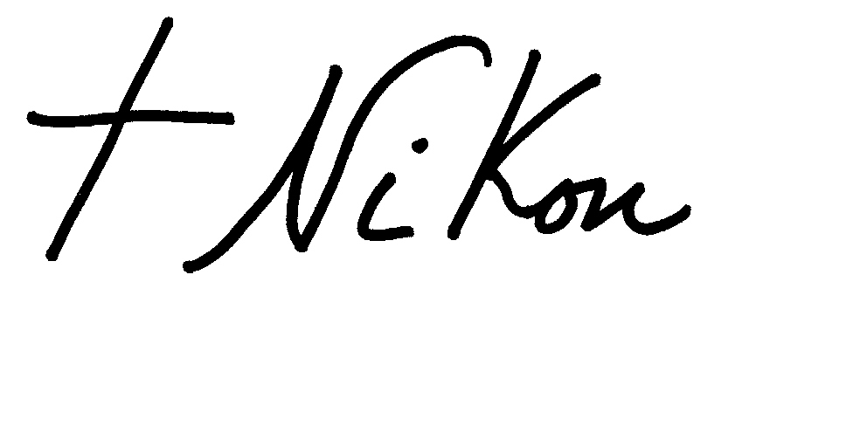

Archbishop of Boston, New England and the Albanian Archdiocese



September 1, 2016

Your Eminence, the Reverend Clergy and Faithful of the Diocese of New England:

Christ is in our midst!

Welcome to Springfield, the citadel of Orthodoxy in Western Massachusetts! Yes! In Springfield we have 6 Orthodox parishes, one of which is the OCA church.

It is truly a great joy, both for our parish family at Saint Peter and Saint Paul Orthodox Church and also me, to host you for the Annual Assembly of the Diocese of New England as our parish marks its 100th year. You are honoring and reaffirming our parish by assembling in Springfield, and our Parish community is ready to serve you as our guests, making sure that you have what you need to deliberate successfully.

On Friday, breakfast, meetings, the meal in between and Vespers will take place in the church. The social hour and dinner will be at the Sheraton Hotel in Springfield. The Hierarchical Divine Liturgy, brunch and final meeting will be on Saturday in the parish, honoring our Centennial achievement

Accommodations for Assembly participants will be at the Sheraton Hotel, One Monarch Place in Springfield. If you are planning to attend the Assembly and need accommodations, please call 1- 413-781-1010 for a room reservation. Blocks of rooms are presently being held for the convenience of Assembly participants for Thursday night, October 27th, and Friday night, October 28th. To ensure that you receive the special room rate of $99.00 plus tax, negotiated for the Assembly, please call the hotel by September 27th and request the “Sts. Peter & Paul Orthodox Church” rate. Also, it is strongly recommended that you have your room at the hotel held for late arrival that evening. So, please call today to reserve your room.

Please send any Diocesan Registration correspondence to our Diocesan Secretary:

Alexia Tassmer

95 South Orchard Street

Wallingford, CT  06492

We look forward to seeing you at the Assembly. In the meantime, if you have any questions or concerns, please do not hesitate to contact us.

Also, we would like to extend our invitation to our Centennial celebration on Saturday after the Assembly ends. A banquet will be held at Chez Josef Hall in Agawam, MA at 2pm starting with a social hour at noon. You can reserve your place by contacting the Chairperson of the Event:

Karen Patruski karenpatruski@yahoo.com (413) 736-6958

Please contact her ASAP to reserve your meal and place.

Yours in Christ,



Priest Michael Korolev



Church parking lot is located on Grosvenor Street, Springfield, MA 01107

**Hotel Information**

Sheraton Hotel, One Monarch Place, Springfield, MA 01144

(413) 781 – 1010 for reservations

Special group rate of $99 per night plus tax ***Rate only through September 27th***

Group name “Sts. Peter & Paul Orthodox Church”

**Driving Directions**

**From Sts. Peter & Paul Orthodox Church**

**118 Carew Street, Springfield, MA**

**To Sheraton Springfield Monarch Place Hotel**

1. Start from church parking lot. Take left onto Grosvenor St.
2. Take the 1st left onto Dwight St. 0.8 miles
3. Turn right onto Harrison Ave. 0.13 mi
   1. Harrison Ave is just past Hillman St
   2. If you reach Falcons Way you've gone a little too far
4. Harrison Ave becomes Boland Way. 0.10 miles

5. Sheraton Springfield Monarch Place Hotel, ONE MONARCH PLACE.

* 1. If you reach E Columbus Ave you've gone a little too far

IconSpringfield Hotels

IconSpringfield Restaurants

**Driving Directions**

**From Sheraton Springfield Monarch Place Hotel**

**to Sts. Peter & Paul Church**

|  |
| --- |
| Monarch Place, Springfield, MA 01144 |

1.1 mi - about 6 mins

|  |  |  |  |
| --- | --- | --- | --- |
|  | 1. | Head northwest on Main St toward Boland Way | 59 ft |
|  | 2. | Turn right onto Harrison Ave | 0.2 mi |
|  | 3. | Turn left onto Chestnut St | 0.8 mi |
|  | 4. | Turn left onto Grosvenor St | 413 ft |
|  |  | Parking lot on left |  |
|  |  |  |  |
| Grosvenor Street, Springfield, MA 01107 | | | | |

On behalf of the members of the Holy Dormition Parish and myself, I am privileged to welcome and to greet you all, in the Name of the Lord.

Archpriest Vasily Lickwar

Parish Rector

The agenda of the assembly, beginning on Friday morning, October 24th, will take place at the Kirkbrae Country Club, 197 Old River Rd, Lincoln, RI 02865 *(401.333-1300, fax 401.333-0050, www.kirkbrae.com),* just a ten minute drive from the Holy Dormition Church. Vespers will also take place at the country club and will be followed there by the customary assembly banquet. On Saturday, a brunch and the assembly's closing plenary session will take place in the parish hall immediately after the Divine Liturgy at the Holy Dormition Church, on Fountain Street off Manville Hill Rd, in Cumberland. Night lodging accommodations are available for all delegates and guests at the Providence Marriot Downtown, One Orms Street, Providence, RI 02904 *(401 272-2400, fax 401 273-2686)* at the special group rate of $149 per room. Reservations must be completed no later than September 30th, 2014, not only to assure securing the group rate but even to secure a room, since the dates of our assembly coincide with local college weekends. **Reservations can be made by telephoning the following toll-free number (866 807-2171) for the group, *Orthodox Church in America, Diocese of New England.***

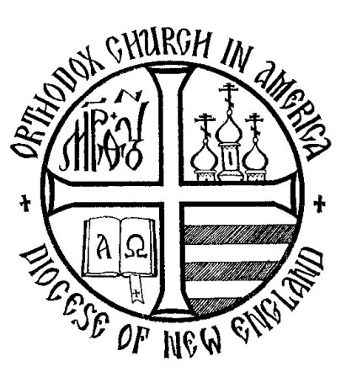

Tentative Schedule

**Time Event Location**

Friday October 28, 2016

8:30 - 10:00 a.m. 53rd Assembly Registration Sts. Peter & Paul Church

10:00 a.m. Opening Service of Thanksgiving Sts. Peter & Paul Church

10:30 a.m. - 12:30 p.m. 1st Plenary Session Sts. Peter & Paul Church

12:30 p.m. - 1:30 p.m. Lunch Sts. Peter & Paul Church

1:30 p.m. - 5:00 p.m. 2nd Plenary Session Sts. Peter & Paul Church

5:30 p.m. Vespers and Confession Sts. Peter & Paul Church

6:30 p.m. Social Hour Sheraton Hotel

7:00 p.m. Banquet Sheraton Hotel

Saturday, October 29, 2016

8:30 a.m. Divine Liturgy Sts. Peter & Paul Church

10:30 - 11:30 a.m. Brunch Sts. Peter & Paul Church

11:30 a.m. - 1:00 p.m. 3rd Plenary Session Sts. Peter & Paul Church

DIOCESE OF NEW ENGLAND

*53rd DIOCESAN ASSEMBLY*

Sts. Peter & Paul Church

Springfield, MA

**OCTOBER 28-29, 2016**



DIOCESE OF NEW ENGLAND

*53rd DIOCESAN ASSEMBLY*

Sts. Peter & Paul Church

Springfield, MA

**OCTOBER 28-29, 2016**

**CLERGY (PRIEST/DEACON) REGISTRATION FORM**

NAME:

ADDRESS: STATE / ZIP:

PHONE: ( ) EMAIL:

PARISH CITY STATE:

SIGNATURE:

**Please RETURN this form by October 8, 2016 to:**

Alexia Tassmer

95 South Orchard St

Wallingford, CT 06492

Any questions please call **Alexia** at 203-284-0856 atassmer@sbcglobal.net

# BANQUET- On Friday evening

# I will attend _____ I will not attend _____

# Meal Choice: ____Pan Seared Atlantic Salmon

# ____Egg Pasta Ravioli

**Please note the Hotel Reservations September 27th Deadline!**



DIOCESE OF NEW ENGLAND

*53rd DIOCESAN ASSEMBLY*

Sts. Peter & Paul Church

Springfield, MA

**OCTOBER 28-29, 2016**

**DELEGATE / ALTERNATE REGISTRATION FORM**

***(Please circle if you are a delegate or an alternate)***

PARISH:

CITY STATE:

*The undersigned has been duly authorized by his/her parish to participate in the 53rdAnnual Diocesan Assembly of the Diocese of New England.*

NAME:

ADDRESS:

CITY STATE / ZIP:

PHONE: ( ) EMAIL:

Signature of Rector

Signature of Parish Secretary

PARISH SEAL

APPROVED:

Credentials

**OFFICIAL STATEMENT DELEGATE / ALTERNATE**

I am a member of my parish in good standing. I have received the mysteries of Confession and Communion at least annually for the past three years at my home parish. I am not under ecclesiastical interdict. I am not married outside of the Orthodox Church. I am not living in violation of Orthodox moral standards. I am not a member of any anti-church and/or secret societies (such as Masonic organizations.) I have contributed the required fair share remittances to the Orthodox Church in America and to the New England Diocese.

**Signature of Delegate / Alternate (Circle One) Date**

*(Any departure from the above mentioned qualifications must be explained on a separate sheet of paper by the observer and the Rector and submitted to the Diocesan Bishop (Administrator) through the Credentials Committee for approval by the Bishop or administrator.)*

**Please RETURN this form by October 8, 2016 to:**

Alexia Tassmer

95 South Orchard St

Wallingford, CT 06492

* Any questions please call **Alexia** at 203-284-0856 atassmer@sbcglobal.net

# BANQUET- On Friday evening

# I will attend _____ I will not attend _____

# Meal Choice: ____Pan Seared Atlantic Salmon

# ____Egg Pasta Ravioli

**Please note the Hotel Reservation September 27th Deadline!**

Pg. 2



DIOCESE OF NEW ENGLAND

*53rd DIOCESAN ASSEMBLY*

Sts. Peter & Paul Church

Springfield, MA

**OCTOBER 28-29, 2016**

|  |
| --- |
| **DIOCESAN LAY COUNCIL MEMBER**  **REGISTRATION FORM**  NAME:  ADDRESS:  CITY STATE / ZIP:  PHONE: ( ) EMAIL:  HOME PARISH:  CITY STATE:  Signature of Rector |

**Please RETURN this form by October 8, 2016 to:**

Alexia Tassmer

95 South Orchard St

Wallingford, CT 06492

* Any questions please call **Alexia** at 203-284-0856 atassmer@sbcglobal.net

# BANQUET- On Friday evening

# I will attend _____ I will not attend_____

# Meal Choice: ____Pan Seared Atlantic Salmon

# ____Egg Pasta Ravioli

**Please note the Hotel Reservation September 27th Deadline!**



DIOCESE OF NEW ENGLAND

*53rd DIOCESAN ASSEMBLY*

Sts. Peter & Paul Church

Springfield, MA

**OCTOBER 28-29, 2016**

**OBSERVER REGISTRATION FORM**

PARISH:

CITY STATE:

*The undersigned observer has been duly authorized by his/her parish to participate in the 53rdAnnual Diocesan Assembly of the Diocese of New England.*

NAME:

ADDRESS: STATE/ZIP:

PHONE: ( ) EMAIL:

Signature of Rector

PARISH SEAL

Signature of Parish Secretary

APPROVED:

Credentials

**OFFICIAL STATEMENT OBSERVER**

I am a member of my parish in good standing. I have received the mysteries of Confession and Communion at least annually for the past three years at my home parish. I am not under ecclesiastical interdict. I am not married outside of the Orthodox Church. I am not living in violation of Orthodox moral standards. I am not a member of any anti-church and/or secret societies (such as Masonic organizations.) I have contributed the required fair share remittances to the Orthodox Church in America and to the New England Diocese. I certify that the above information is true. I also understand that as an observer, I may not speak or vote on any matter on the assembly floor.

**Signature of Observer Date_______**

(Any departure from the above mentioned qualifications must be explained on a separate sheet of paper by the observer and the Rector and submitted to the Diocesan Bishop (Administrator) through the Credentials Committee for approval by the Bishop or administrator.)

**Please RETURN** with the **Assembly Fee of $70.00** per person.

**Please RETURN this form by October 8, 2016 to:**

Alexia Tassmer

95 South Orchard St

Wallingford, CT 06492

* Any questions please call **Alexia** at 203-284-0856 atassmer@sbcglobal.net

# BANQUET- On Friday evening

# I will attend_____ I will not attend_____

# Meal Choice: ____Pan Seared Atlantic Salmon

# ____Egg Pasta Ravioli

**Please note the Hotel Reservation **September 27th** Deadline!**

The **Assembly Fee** covers all the reports, all meals and the banquet.

***Checks are payable to the DIOCESE OF NEW ENGLAND.***

Pg. 2